**JPI Oceans**

**Call for proposals titled**

**“Underwater Noise in the Marine Environment”**

Dear potential research partner,

After having received the attached Joint Call for Proposal titled “Underwater Noise in the Marine Environment”, regarding the JPI Oceans research funding scheme, I write you for exploring the possibility to present a proposal including our research unit as a partner. The deadline of the call is 28 February 2022, so there is short time for acting!

In the following we shortly provide the information of the previous research done here at the University of Parma on topics relevant for this call, regarding mostly underwater acoustics measurements and evaluation of the effect of sound on marine species.

We think that our research unit can provide significant synergy with the activity of other research groups, as we carry two “novelties” not available elsewhere, which can help the proposal to be financed.

These two novelties both come by significant innovative steps which we already accomplished in other field of acoustics (not underwater), and which we already tested successfully also for underwater measurements.

In the following chapters I try to explain briefly these two approaches, leaving to the existing publications the task of providing a more formalized explanation. And, of course, I am available for provide further information and documents, as we already have a lot of material ready to be employed when writing the proposal for this JPI Oceans call.

1. **Background**

The Call for Proposals titled “Underwater Noise in the Marine Environment” already contains a list of the “hot topics” which are addressed. Among them, two stand out, where our expertise can provide a significant innovative step:

1. Evaluating the effect of noise on marine species different from mammals, recording underwater soundscapes and assessing their effect on different species, taking into account also of spatial aspects of noise pollution with respect to Marine Reporting Units.
2. Developing methods for impulsive acoustical measurements avoiding the impact of strong impulsive sound sources currently widely employed for oceanographic and seismic surveys, such as air guns

The first topic constitutes the core of Theme 1 of the call, described in chapter 3.1 (page 14 of the attached document) – and the relevant point is the following phrase:

*“The risk for animal populations from acoustic disturbance is a function of acoustic signal characteristics (****including particle motion****), biological species identity, and the ambient environmental conditions.”*

So, the call for proposals asks specifically to consider also the effect of particle motion, and not just of sound pressure. Our research group has been a pioneer in the field of recording and measuring the three Cartesian components of underwater particle velocity, and in assessing the effect of this quantity on marine species possessing sensorial systems sensible to particle motion, instead of sound pressure. In chapter 2 we provide a small resume of this previous activity, and we propose new development in this field, both regarding recording underwater soundscapes employing pressure-velocity probes and building playback system capable of reproducing both the sound pressure field and the particle velocity field in laboratory conditions, for making it possible to make experiments on the effect of these acoustical quantities on living samples of different species.

The second topic instead, is the core of Theme 2, described on chapter 3.2 (page 15 of the attached document). In this case the relevant phrase is the following one, the first of Theme 2’s description:

*“Industry and researchers should work closely together to address the challenge of developing* ***alternative more quiet acoustic sources*** *for geophysical exploration of comparable efficiency, which, at the same time, cause a lower impact on marine fauna”.*

We already have the solution for this problem, as we invented the method known as Exponential Sine Sweep, which, starting from year 2000, progressively replaced all the methods employing impulsive sources which were previously employed when performing measurements of acoustical impulse responses, both indoors and outdoors, in fields such as architectural acoustics, archeoacoustics, building acoustics and characterisation of the acoustical properties of materials.

In the past 20 years the ESS method was progressively adopted as the standard method in many fields of acoustics for its great advantages, requiring a sound source of small power, for being resilient to nonlinearities, background noise, and time variance of the system being measured, and for being highly customizable to the characteristics of the transducers employed and of the environment where the impulse response has to be measured.

The following chapter 3 describes the genesis of this measurement method, his initial rapid success for acoustical measurement in large rooms, and then its adaptation to various other fields of application, including underwater acoustical measurements.

1. **Particle velocity: the forgotten quantity**

In the last few years, the importance of assessing the environmental impact caused by underwater noise generated within human activities has grown significantly, mainly due to the effects found on the fishery industry and from the reduction of marine protected areas.

Many surveys and tests have been performed to evaluate the effect of noise on marine species. However, in most cases, the only physical quantity being measured was the sound pressure to which are typically sensitive mammals and birds. Conversely, there is strong experimental evidence that most marine species do not have sound pressure sensors. Instead, the sensorial system they are equipped with can detect mostly kinematic quantities such as water particle velocity. This vector quantity carries the spatial information of the sound field, making it possible to distinguish the Direction-of-Arrival (DoA) of sounds, that is the source localization capability.  
At the beginning of each Acoustics course, it is explained how a sound field is a region of space, filled with a fluid, where the propagation of elastic waves causes both pressure fluctuations ad particle motion.

Unfortunately, most acousticians, working either in air or underwater, seem to have forgotten these basic concepts, and assume that particle velocity is just proportional to sound pressure, which in general is not true.

The loss of proportionality between sound pressure and particle velocity also happens underwater, particularly close to the coastline, where the particle velocity becomes substantially independent from sound pressure.

Only recently the above concepts have been accepted by the scientific community [1] and even today several research projects are conducted measuring and evaluating just sound pressure (see [2], for example).

Moreover, the sound pressure recorded by a normal microphone or hydrophone is an “omnidirectional” quantity, without any directional information, while a particle velocity sensor is sensitive also to the Direction-of-Arrival of the sound wave. Hence, to fully describe the sound field in a point of the space a special probe capable of recording both pressure and the three Cartesian components of particle velocity is required, and this has been made possible by the pioneering work of a British scientist, Michal Gerzon, in the seventies of past century, developing a complete physical description, a recording method, and a reproduction method, globally known as the Ambisonics technology [3]. Ambisonics is an elegant mathematical and physical theory, employing spherical harmonics functions for describing the spatial properties of the sound field. Gerzon also built, with Peter Craven, a compact microphone array named Soundfield Microphone, capable of recording 4 signals, proportional to sound pressure (W) and to the three components of particle velocity (X,Y,Z) [4].

The first attempts of bringing the Ambisonics technology underwater date back to 2009, when we first assembled a tetrahedral probe of four hydrophones, conceptually similar to the Soundfield microphone [5]. From that time, we developed several other underwater hydrophone arrays, even more complex, and capable of spatial analysis with sharper resolution. On the other side, we also explored the effect of underwater noise carried by particle velocity on some underwater animals [6,7,8]. Later on, we studied the effect of the geometry of shelters causing acoustical amplification of sound pressure and particle velocity signals [9, 10] and tested a new method for computing the filter matrix required for retrieving these signals from a generic multi-hydrophone array [11].

More recently we published two papers summarising out knowledge on the evaluation of underwater noise employing pressure-velocity probes [12,13].

In this photo you can see our first pressure-velocity probe, deployed in the Adriatic Sea, at the Trieste-Miramare marine protected area in 2009:

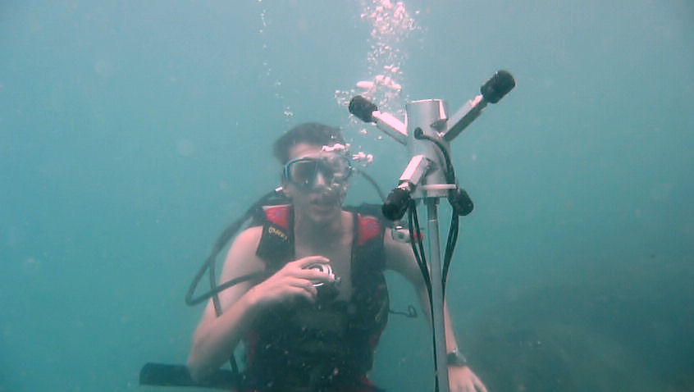

Fig. 1 – tetrahedrical hydrophone array deployed in Miramare MPA - 2009

In this photo you can see our latest spherical hydrophone array, also equipped of a panoramic VR camera, first tested at Giglio island in August 2019 and later at Panarea island in September 2019 for measuring the noise produced by volcanic emission of CO2 from the sea bed:

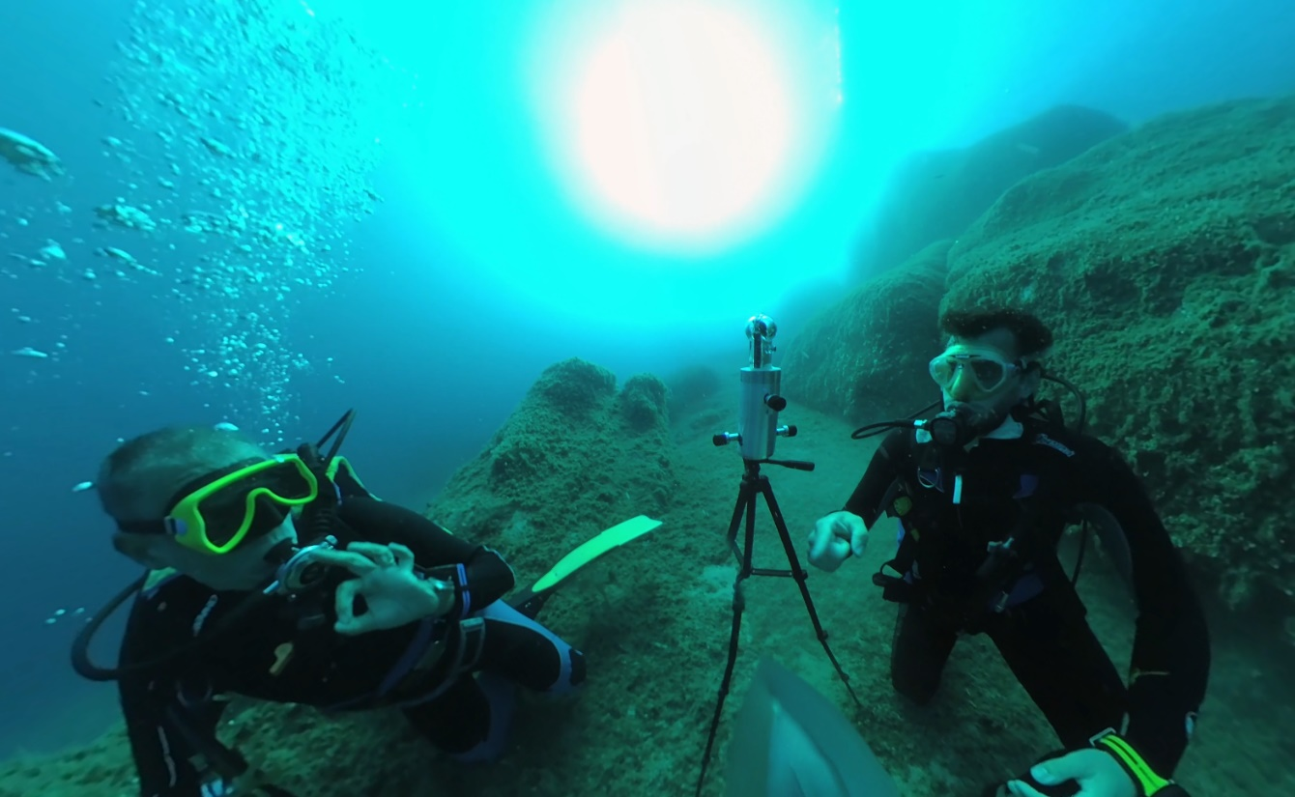

Fig. 2 – New audio-video recording system employed at Isola del Giglio, August 2019

The following video was taken with the above camera and hydrophone array (panoramic 360° with Ambisonics spatial audio and superposed vector colour map, showing the direction of arrival of sound waves) and can be seen on Youtube at the following link: <https://youtu.be/FOYARFSlg8U>

The future of underwater particle motion measurements looks bright, thanks to the fact that the Ambisonics theory is “hierarchical”: the spherical harmonics functions, in fact, do contain functions of order zero (sound pressure) and order one (the three Cartesian components of particle velocity). There are spherical harmonics of increasing order, as shown in fig.3:

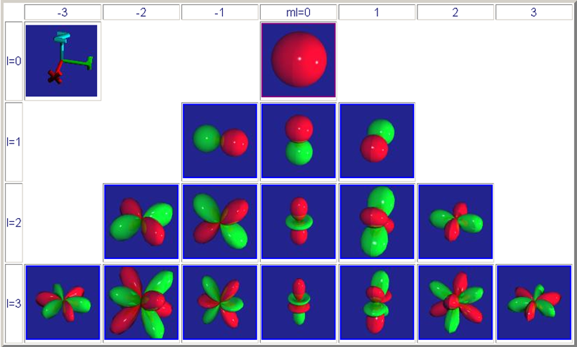

Fig. 3 – Spherical harmonics functions of orders 0,1,2,3

It is possible to record (and reproduce) a three dimensional sound field with improved spatial accuracy employing a massive array of transducers, resulting in multichannel recordings with increasing number of channels: 9 for SH up to 2nd order, 16 for SH up to 3rd order, 25 for SH up to 4th order, and so on, up to 64 ch. for SH up to order 7, which nowadays is the practical limit possibly reachable with available hardware and software.

In fig. 4 we show our prototype of a 2nd order spherical hydrophone probe, employing 12 transducers placed on the surface of a rigid sphere:



Fig. 4 – novel 2nd-order Ambisonics underwater hydrophone array

The other novelty we plan to exploit in this EU-funded project is the capability of controlling the particle velocity in artificial sound fields generated with an array of underwater loudspeakers. Till now, all the experiments conducted on live animals, both in captivity or in nature, were conducted stimulating them with underwater artificial sound sources which were controlled only in terms of generated sound pressure. But the particle velocity effectively eliciting the animal’s sensorial system was unknown, or, even if estimated on some way, it was impossible to control the particle velocity independently from the sound pressure.

One of the important outputs of the Ambisonics technology is the capability of controlling the pressure-velocity relationship in the artificial sound field generated at the center of a loudspeaker array.

Using just a pair of opposite loudspeakers it is possible to control one Cartesian component of the particle velocity independently from the sound pressure, as shown in fig 5.

Fig. 5 – a pair of opposite loudspeakers stimulating a fish with independently-controlled sound pressure and one-dimensional particle velocity

Of course, for controlling simultaneously the three Cartesian components of particle velocity and the sound pressure a massive three-dimensional loudspeaker array is required, as shown in fig 6:



Fig. 5 – a massive spherical loudspeaker array stimulating a fish with independently-controlled sound pressure and three-dimensional particle velocity

So, the goals of the research project can be summarised as follows regarding Theme 1:

1. Building and testing a massive hydrophone array capable of capturing both sound pressure and particle motion signals, with high spatial resolution obtained extending current Ambisonics technology to high order spherical harmonics (at least 3rd order)
2. Performing a number of surveys in different coastal environments, recording High order Amsbionics soundscapes, either in “silent” areas for analuyzing the natural background, and in areas with significant impact of anthropogenic noise, due to boats, ships, factories and coastal constructions (piling, scraping, etc.)
3. Building a three-dimensional playback system making use of a number of underwater loudspeakers and of proper hardware and software for feeding them with controlled signals, capable of replicating the sound pressure and simultaneously the particle motion of the soundscapes recorded in b) or providing artificial stimuli aimed to analyze the behavioural and physiological response of marine animals, when stimulated by sound pressure (with no particle motion) or by particle velocity (with no sound pressure).
4. **Measuring impulse responses without emitting impulses**

Acoustical impulse responses have been measured since almost 100 years and constitute one classical method for analyzing the acoustical response of a system, and for extracting information on his nature and structure.

In the sea, a number of impulsive methods have been developed, using different types of emitters, ranging from very short sinusoidal ultrasonic bursts emitted by SONAR devices, and moving to sparkers and air guns for geo acoustical measurements, where lower frequencies and wider bandwidth are required for penetrating in the sea bed and retrieving information on objects buried in it and detecting the stratigraphy of the geological structures even kilometres below the sea bed.

Whilst ultrasonic devices can operate with limited power and are generally producing very minimal environmental impact as most marine species are insensible to ultrasound, electrical sparkers and air guns causse instead a lot of acoustic pollution and have often been associated with evident biological effects both on marine mammals and on fishes.

However, when the signal has to penetrate for kilometres in the solid structure, and when the environmental noise is large, a very powerful impulsive sound source is required for attaining a decent signal-to-noise ratio.

However, an impulse response is, by definition, the response of the signal of a finite-energy stimulus. Given a certain amount of energy associated with the impulse, the shorter the impulse and the larger must be the power. Conversely, the only way of reducing the power required is to 2dilute the impulse over time, and then to employ some sort of mathematical processing of “packing” the system0s response, so that it comes back almost perfectly to the response of the same system when stimulated by a very short pulse.

Two methods were employed for obtaining this goal, named MLS (maximum Length Sequence) and TSP (Time-Stretched Pulse, a.k.a. “chirp”). The first had initially a wide success for applications in electroacoustics and room acoustics [14], and we also attempted to use it underwater, but the results were not so good [15]. The second instead was also used in electro acoustics and room acoustics [16], but with less success than MLS, and instead had some better success in underwater acoustics [17].

Both methods had their problems, indeed, mostly related to artefacts occurring when the system was performing not perfectly linearly, as the methods employed for “packing” the recorded signal were employing mathematical methods only valid for perfectly Linear, Time Invariant systems (LTI).

But in 1999 we changed everything, developing and releasing the Exponential Sine Sweep method [18]. The usage of this test signal, and of a proper deconvolution method for “packing” the resulting response, allowed to deal with systems with strong nonlinearities, and also to deal efficiently with background noise and with the temporal variance of the system under test. Albeit the ESS was initially not understood entirely by the scientific community, after some years almost all the manufacturers of acoustical instruments included the ESS method in their systems, replacing the ESS and the TSP signals.

Only in underwater acoustics, till now, the ESS method is scarcely employed. We think that it has the potential of making air guns obsolete, as it happened in room acoustic, where firecrackers, pistol shots or balloon explosion were entirely obsoleted.

However, the usage of the ESS signal underwater requires the development of a new generation of underwater loudspeakers, optimised for playing back sinusoidal signals starting form very low frequency. For replacing air guns, the underwater loudspeaker must radiate sound efficiently in a wide frequency range, and low frequencies are required for penetrating in the seabed.

After the attempt of using the MLS signal for underwater measurements [15], we employed successfully the ESS signal for active sonar measurements [19], also employing hydrophone arrays for improved acoustical imaging [20].

In the following figure a low-cost, low-power, wide-band underwater loudspeaker capable of working in the same frequency range as air guns is shown, as first employed in [21] for ESS measurements:

Fig. 6 – low-cost, wide-band underwater electrodynamic loudspeaker

Of course, the acoustical power of such a sound source is roughly 1/1000000 of the power of an air gun, resulting in a sound pressure level, at a given distance, which is roughly 60 dB weaker. This ensures to avoid the dramatic impact of air guns on marine life.

On the other side, the deconvolution of an ESS signal of proper length (say, 15 to 30 seconds) provides a boost of the signal-to-noise ration around 60-70 dB, resulting in a measured impulse response with the same signal to noise ratio as the one obtained with an air gun. The ESS signal provides further advantages, making it possible to better exploit the performances of a given transducer, limiting the sound emission within the frequency range where the loudspeaker operates efficiently and safely. A number of improvements on the original ESS methods have been developed, allowing for measurements completely immune form artifacts due to non-linearities, time variance and external noise events [22].

1. **Conclusions**

Our previous experience in underwater acoustics measurements and in evaluation of the effect of noise on marine animals provides a perfect match with the requirements of the recent call for proposals under the JPI Oceans framework, titled “Underwater Noise in the Marine Environment”.

This document contains a quick presentation of the main results of the research conducted during the past 25 years on these topics at the University of Parma, ITALY. Our labs are already equipped with most of the required hardware and software, and our researchers possess the knowledge and the expertise for using them properly. We have novel ideas on improvements boing beyond the current state of the art, both regarding sensors to be employed for higher-resolution vector analysis of the sound field, and for building a new generation of underwater loudspeakers capable of replicating the same measurements currently performed with air guns employing a small fraction of their acoustical power.

Becoming research partner of a project financed by this JPI Oceans call for proposals, our team could provide substantial benefit to the other participants, making available our recording and measurement systems, and our expertise in signal processing and evaluation of the results.

We are currently not constrained by any previous work done with industrial partners, and we have full intellectual property on the advanced methods developed in our labs.

We will be happy to evaluate proposal of cooperation both with industrial partners and public research labs for assembling a successful proposal of a research projects regarding both main themes of the cited call for proposals.

Sincerely Yours

Parma, 20 January 2022

Angelo Farina, Ph.D.

Full Professor of Applied Acoustics

**REFERENCES**

[1] Nedelec, S.L., Campbell, J., Radford, A.N., Simpson, S.D. and Merchant, N.D. (2016), “Particle motion: the missing link in underwater acoustic ecology”. Methods Ecol Evol, 7: 836-842. <https://doi.org/10.1111/2041-210X.12544>

[2] SOUNDSCAPE – “Soundscapes In The North Adriatic Sea And Their Impact On Marine Biological Resources” – Interreg Italy-Croatia EU project, Environmental and Cultural Heritage - SO 3.2 - <https://www.italy-croatia.eu/web/soundscape/about-the-project>

[3] M. A.. Gerzon, "Periphony: With-Height Sound Reproduction," J. Audio Eng. Soc., vol. 21, no. 1, pp. 2-10, (1973 February.). <https://www.aes.org/e-lib/browse.cfm?elib=2012>

[4] P. G. Craven, M. A. Gerzon – “Coincident microphone simulation covering three dimensional space and yielding various directional outputs” – US Patent no. 4,042,779 – filed July 7, 1975, published Aug. 16, 1977 - <https://patentimages.storage.googleapis.com/85/0c/50/591f5a219cc8be/US4042779.pdf>

[5] Angelo Farina, Adriano Farina, Enrico Armelloni, Linda Sebastianutto, Carlo Franzosini, Marta Picciulin – “First description of the sound pressure and particle velocity components of the ambient noise and boat noise recorded at the WWF- Miramare Natural Marine Reserve (Trieste, Italy)” - Second International Conference "The Effect of Noise on Aquatic Life" Cork, Ireland, August 15-20 2010 - <http://www.angelofarina.it/Public/Papers/250-Cork-2010.pdf>

[6] Lugli M., Fine M.L. - “Stream ambient noise, spectrum and propagation of sounds in the goby Padogobius martensii: sound pressure and particle velocity”. J Acoust Soc Am. 2007 Nov;122(5):2881-92. <https://doi.org/10.1121/1.2783113>

[7] Marta Picciulin, Linda Sebastianutto, Antonio Codarin, Angelo Farina, Enrico A.Ferrero – “In-situ behavioral responses to boat noise exposure of Gobius cruentatus and Chromis chromis living in a Marine Protected Area” - Journal of Experimental Marine Biology and Ecology, Vol. 386 (2010), pp. 125–132, ISSN 0022-0981 - <https://doi.org/10.1016/j.jembe.2010.02.012>

[8] Lugli M. – “Habitat Acoustics and the Low-Frequency Communication of Shallow Water Fishes”. In: Ladich F. (eds) Sound Communication in Fishes. Animal Signals and Communication, vol 4. Springer, Vienna, 2015. <https://doi.org/10.1007/978-3-7091-1846-7_6>

[9] Lugli M. – “ Acoustics of fish shelters: frequency response and gain properties” – J. Acoust. Soc. Am. 2012 Nov;132(5):3512-24. <https://doi.org/10.1121/1.4754581>

[10] Lugli M. – “Acoustics of fish shelters: background noise and signal-to-noise ratio” – J. Acoust. Soc. Am. 2014 Dec;136(6):3382. <https://doi.org/10.1121/1.4901707>

[11] Angelo Farina, Enrico Armelloni, Lorenzo Chiesi – “Experimental Evaluation Of The Performances Of A New Pressure-Velocity 3D Probe Based On The Ambisonics Theory” - 4th international conference and exhibition on Underwater Acoustic Measurements: Technologies and Results - Kos (Greece), 20-24 June 2011 - <http://www.angelofarina.it/Public/Papers/256-UAM-2011.pdf>

[12] Angelo Farina – “Environmental Impact of Underwater Noise: sound pressure and particle velocity” - ICONS-2018, Kochi, India, 22-24 February 2018 - <http://www.angelofarina.it/Public/Papers/286-ICONS2018.pdf>

[13] Angelo Farina, Enrico Armelloni, Daniel Pinardi – “The Forgotten Measurement: Sound Pressure and Particle Velocity” - Environment Coastal & Offshore Magazine - Special Issue on Ocean Sound - July 2019 - ISSN # 2327-3445 - <http://digital.ecomagazine.com/publication/frame.php?i=598395&p=47&pn=&ver=html5>

[14] J. Vanderkooy - “Aspects of MLS measuring systems” - Journal of the Audio Engineering Society (1994) 42(4): 219-231. - <http://www.aes.org/e-lib/browse.cfm?elib=6951>

[15] Angelo Farina – “MLS Impulse Response Measurements For Underwater Bottom Profiling” - 4th European Conference on Underwater Acoustics, Rome, 21-25 September 1998 - <http://www.angelofarina.it/Public/Papers/116-ECUA98.PDF>

[16] G. Stan, J. Embrechts, and D. Archambeau, "Comparison of Different Impulse Response Measurement Techniques," J. Audio Eng. Soc., vol. 50, no. 4, pp. 249-262, (2002 April.). - <http://www.aes.org/e-lib/browse.cfm?elib=11083>

[17] Lester R. LeBlanc – “Marine sediment classification using the chirp sonar” - Journal of the Acoustical Society of America 91, 107 (1992); <https://doi.org/10.1121/1.402758>

[18] A. Farina – “Simultaneous measurement of impulse response and distortion with a swept-sine technique” - 108th AES Convention, Paris 18-22 February 2000 - <http://www.aes.org/e-lib/browse.cfm?elib=10211>

[19] E. Armelloni, A. Farina, L. Burgalassi – “Not-Impulsive Techniques for Sonar Imaging” - International Conference “Underwater Acoustic Measurements: Technologies &Results” Heraklion, Crete, Greece, 28th June – 1st July 2005 - <http://www.angelofarina.it/Public/Papers/208-UAM2005.pdf>

[20] Enrico Armelloni, Fons Adriaensen, Angelo Farina – “Passive and active Sonar applications for a non-uniform and low cost Linear Array” - Underwater Acoustics Measurements: Technologies & Results - Nafplion, Greece, 21-26 June 2009 - <http://www.angelofarina.it/Public/Papers/248-UAM-2009.pdf>

[21] Gaggero Tomaso, Tani Giorgio, De Angelis Emilio, Firenze Erica, Farina Angelo, Armelloni Enrico – “On site propagation loss measurements through non-impulsive signal deconvolution” - 25th International Congress on Sound and Vibration 2018, ICSV 2018, Hiroshima, Japan, 8-12 July 2018 - <http://www.angelofarina.it/Public/Papers/291-ICSV25-2018.pdf>

[22] A. Farina – “Advancements in impulse response measurements by sine sweeps” - 122th AES Convention, Vienna, Austria, 5-8 May 2007 - <http://www.aes.org/e-lib/browse.cfm?elib=14106>