First topic: NATURE OF SOUND
Sound is generated, but not only made, by pressure fluctuations, which are what human can perceive through air.
We must deal with quantities that relate to the nature of sound and other
ones that are prettily descriptive, such as amplitude, frequency, period and wavelength.
It’s important to underline that there is no mass-transfer: it seems like a contradiction but there’s no air coming out from speakers’ mouths and arriving to listeners’ ears.

To have sound we must have BOTH
- SOUND SOURCE and an
- ELASTIC MEDIUM

The sound source is the object where energy occurs and is transformed, usually mechanical energy is transformed into acoustic energy.
To hear sound far from the source, an elastic medium, or an almost elastic medium is needed. Otherwise a bit of energy is dissipated and sound extinguishes in a few meters.

Let’s imagine a cylindrical and infinitive long tube like this:

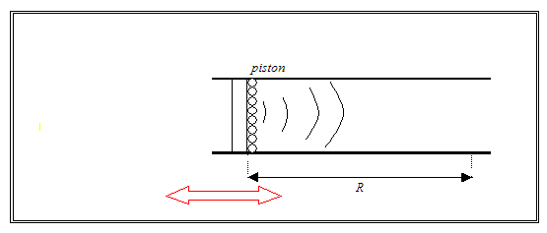

The piston moves back and forth along the axis of the pipe.
The law that describes the particle movement is a harmonic law:
$$s=so cos(t)$$
where ω= pulsation of angular velocity
t= time in seconds
The piston in 2 s_{o} long, half length on the left and a half on the right of “zero”, which is the origin of the axis.

We impose a motion to the air moving the piston: when the piston in on the left, it leaves more space and air expanses, when the piston is on the right, on the other hand, air is locally compressed because there is less volume available.
Pressure fluctuations propagate through the tube.

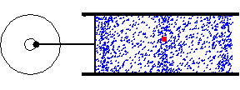

If we look at the motion of one particle we see that it moves back and forth, it does not go away. What flows through the right is the wave.
So with “speed of sound” we mean the speed of the wave, it’s up to the characteristics of the medium e not on weakness or loudness of sound.
The “velocity” is the speed of particles. It can be high or slow if the particles move fast o slowly.

Here are three important quantities and their relationships:
- f= frequency the number of circles performed by the planar surface in one second, misured in Hertz.
- T= period time required to make a complete circle.
- ω = angular velocity (rad/sec)

f = 1/T and f = ω/ 2π

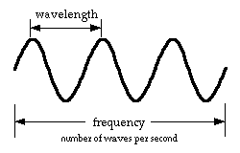
wavelength = distance between two
peaks of the wave

The phenomenon that occurs between 20 and 20,000 Hertz is called “sound” and it can be perceived by humans, below 20 Hertz it is called “infrasound”, above 20,000 Hertz it is called “ultrasound”.

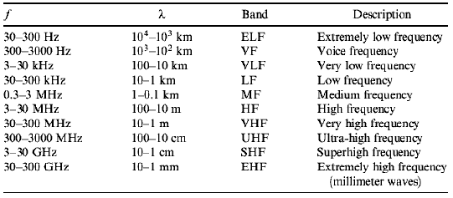

There are three kinematical descriptors of the motion of a body:
- Displacement : $s = so cos(t)$
- Velocity : $v = ds/dt$ $=$ $-so sen ( t)$
- Acceleration: $a = dv/dt$ $=$ $-$ ${}^{2} so cos( t)$

If the piston is connected to a rotating wheel, the displacement, or in other words the distance between the centre of the wheel and the centre of the rotatable piston, is constant, but we can make the system move faster or slower.

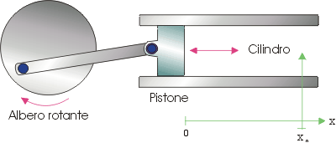

The main quantity is velocity for two reasons: it is proportional to pressure and what we hear is pressure, and the energy involved is proportional to the square of velocity.

The sound speed in air is:
$$c= \sqrt{γRT}$$
$γ=1.41$ constant that comes from the adiabatic law
$R=287\frac{J}{kgN}$ constant of perfect gas law for air
$T=t+273 K$ absolute temperature

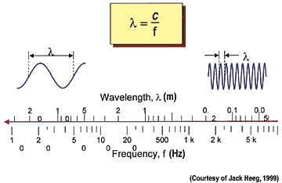

The last formula to know is:
$c= \sqrt{\frac{E}{ρ}}$
E= elastic moduluse (N/m²)
ρ= density (kg/m³)

The higher E is and the smaller ρ is, the faster the sound travels.
Air is an elastic medium, so E is small, but this does not mean that air is not a good medium beacause air is very light!
At 20°C $c=340 \frac{m}{s}$

